# Synthesis Development Tips

## Related code

My latest Synthesis code is in the branch called “**synthesis-mt**”.

The new Angular front end UI is in “<src>\software\cananolab-client-new”. The Synthesis UI code is in “cananolab-client-new/src/app/cananolab-client/main-display/samples/synthesis”.

Inside the folder, the “synthesis\” module is for the overall Synthesis view which show the data summary for all the types. The “materials\”, “functionalization\” and “purification\” modules are used for the edit page of those tabs.

The backend code is in “<src>\software\cananolab-webapp”. These four classes are used to handle the RESTful calls from the front end. You can follow them by put breakpoint in the GET/POST handle functions.

SynthesisFunctionalizationServices.java

SynthesisMaterialServices.java

SynthesisPurificationServices.java

SynthesisServices.java

## Development

Develop Angular front end is convenient if you use “ng serve”. It will reload your change automatically when you save change. The steps are:

1. Install Angular CLI: <https://angular.io/cli>
2. Start serve the front end by running:

<src>/software/cananolab-client-new\> **ng serve --proxy-config proxy.conf.json**

1. It will take a while, and when it is compile success it will host at [**http://localhost:4200/#**](http://localhost:4200/)
2. You need to log in a curator account (for example: “canano_curator” is used in the test sql tables for Synthesis) to test Synthesis. You may need to set a new password in the canano db’s user table.
3. After login, go to Samples, create new or search existing. And once you select a sample, you will see “Synthesis” tab on the left side.

This is a good sample to test synthesis: <http://localhost:4200/#/home/samples/synthesis/1000>

Develop backend need to deploy the server. Please see other documentation no how to do it. The steps are “ant deploy_local” and run “deploy-change.sh” to the WildFly server.

If you need to run the old AngularJS version of Synthesis, you need to:

1. Download **WildFly 8.2.1.Final** and start a local server. See other documentation.
2. Sync master branch of <https://github.com/CBIIT/cananolab>.
3. Build it and deploy the cananolab.war to the server. See other documentation.
4. The synthesis UI in the old front end is hidden, so you need to change the URL manually to “editSynthesis”. For example: <http://localhost:8080/#/editSynthesis?sampleId=1000>.

## Debug

**Front end**

1. Right click and press “inspect”
2. Find the compiled js file, find the function, and click breakpoint.

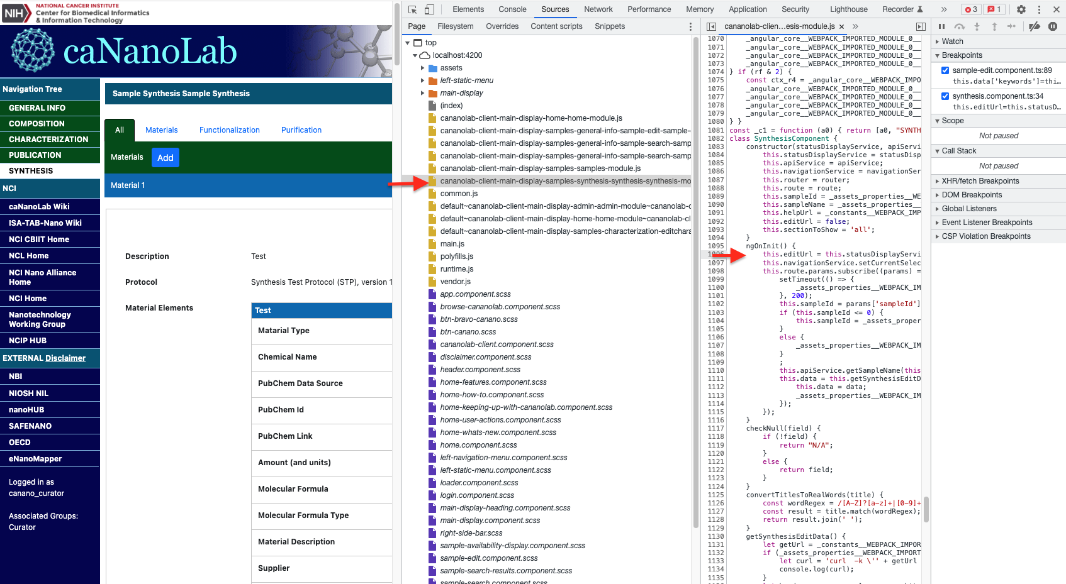

1. It will actually select the correct source code in the ts (Typescript) file.
2. Breakpoint will hit in the ts file when you reload again.

**Back end**

See other Documentation about how to debug WildFly server in IntelliJ.

If you see error in **TabGenerationBOTest.java** file, you can comment out that function.